Git

Version Control – Git

Control Server –Git Hub

Copy URL – Git Clone

git clone <url>

git add <file name>

git commit -m “message”

git status

git push

git pull

git log

git reset --hard <commit>

git reset --hard original/Master

web $ cd src

src $ open hello.html

**Git Branching and Merging**

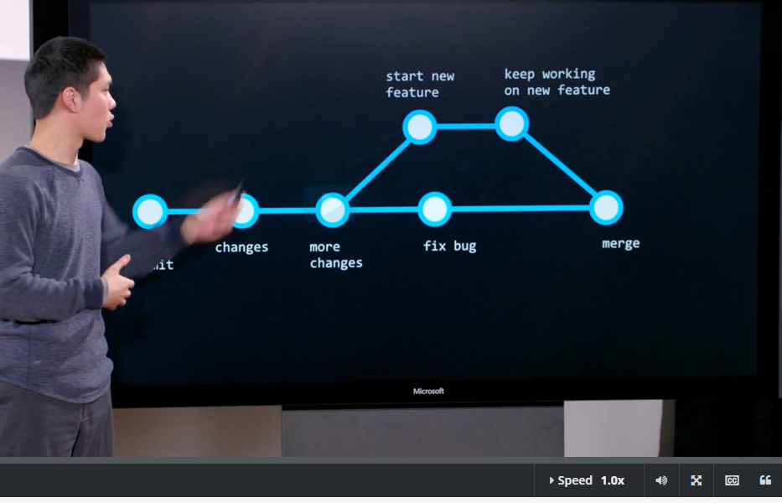

CSS

Difference between margin and padding

<link rel=”stylesheet” href=”styles.css”>

Margin= distance outside the box and page

Padding= distance inside text and box

**Difference between # and .**

<!DOCTYPE html>

<html>

<head>

<title>

</title>

<style>

    #top{

font-size: 100px;

    }

    #middle{

font-size: 70px;

    }

    #bottom{

font-size: 20px;

    }

    .name

    {

        font-weight: bold;

    }

</style>

</head>

<body>

<div id="top">

 This is the <span class="name">top </span> of my web page

</div>

<div id="middle">

This is the <span class="name">middle</span> of my web page

</div>

<div id="bottom">

This is the <span class="name">bottom</span> of my web page

</div>

</body>

</html>

#= It is used for Id in div tag

.= It is used for class

But # and ., both are CSS class.

<https://github.com/me50/prize-max.git>.

<https://cs50.readthedocs.io/submit50/>

**Python**